What Google research shows about ‘journaling’

<https://www.nytimes.com/2018/10/25/style/journaling-benefits.html>

“What’s All This About Journaling? (One of the more effective acts of self-care is also, happily, one of the cheapest.”

Labeling emotions and traumatic events - incorporated into traditional talk therapy

Writing - organizational system (organize an event in our mind, and make sense of trauma), working memory improves, sleep better

기록의 종류: journaling, time tracking (recording the time you have spent on a particular task) - spreadsheets, app

<https://www.softwaretestinghelp.com/time-tracking-software/>

----

Benefits of time tracking:

1. Beating procrastination

2. Understanding your productivity

3. Keeping track of your progress

Journaling - mental stress

1. 삶의 방향을 알려준다

2. 자아성찰

3. 다짐하고 실천하게 된다

Methods of time tracking:

1. Timer systems. The simplest timesheets with timers allow recording total hours worked. To start tracking, an employee simply has to press a button. More complex tools let you allocate time to different job assignments (e.g. projects or tasks).

2. Background tracking systems. They are based on desktop monitoring which limits the target audience to office workers.

3. Systems with manual recording. A user logs time against a task manually, either as an interval or amount of time. Built-in notifications will remind employees when it’s time to fill in the timesheet.

References: <https://www.actitime.com/time-tracking/time-tracking-software-essay/>

1. 삶의 방향을 알려준다

2. 자아성찰

3. 다짐하고 실천하게 된다

<https://brunch.co.kr/@sterdam/1141>

4. Productivity Journal (manual)

------

“Time Tracking Experiment: What I Learned After Analyzing Every Minute of My Life for 30 Days”

Categories for time tracking:

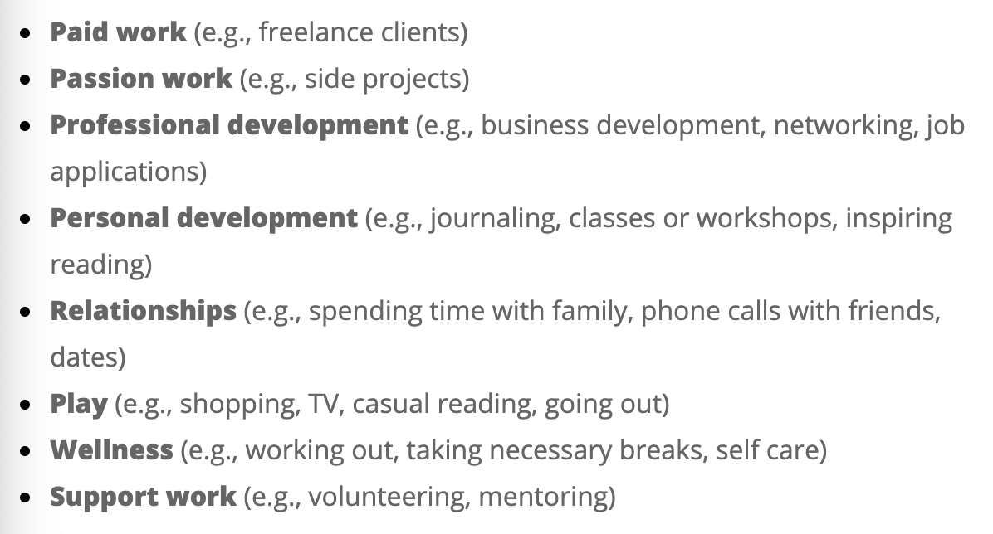

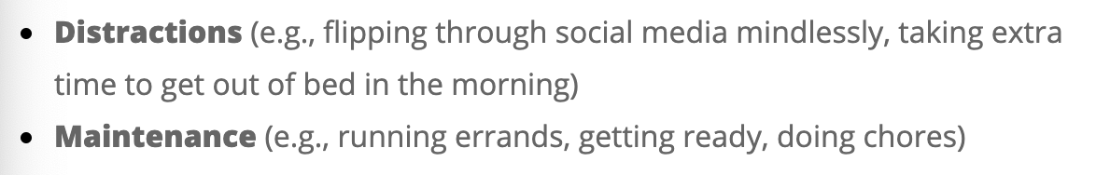

How to spend time (example):

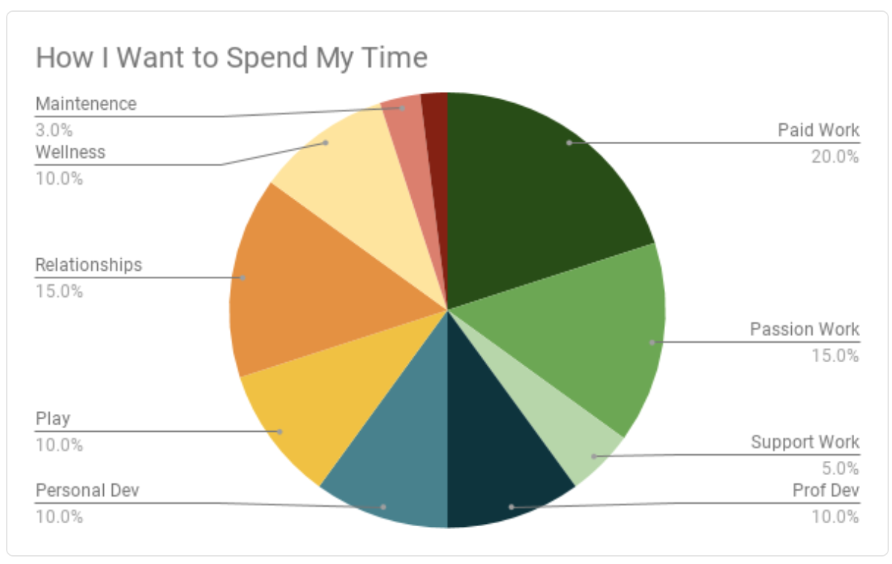

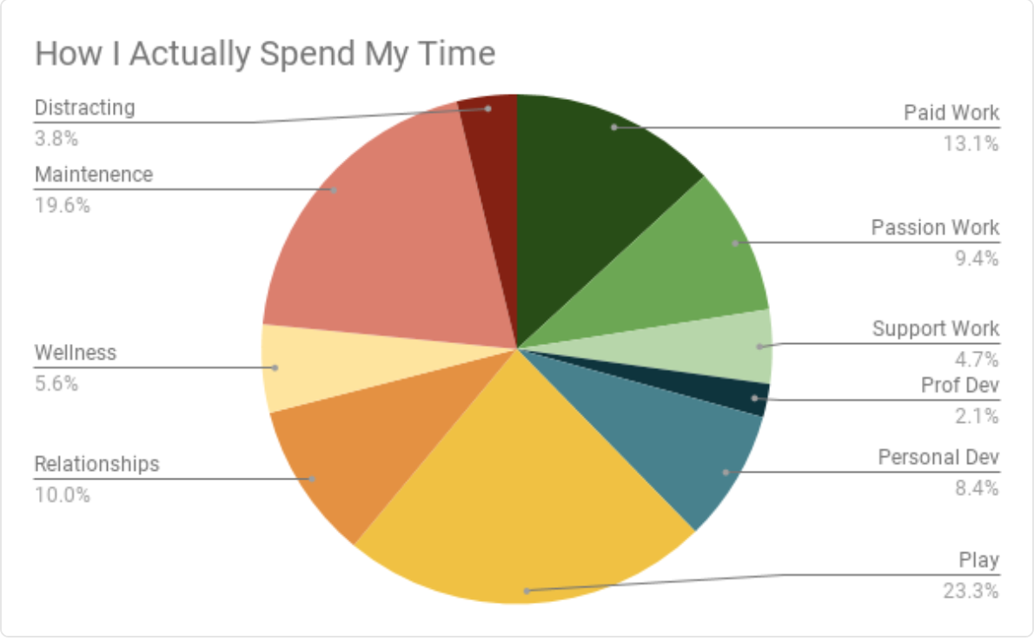

The user found himself/herself:

1. Being more conscious of time

2. Limiting multitasking

References: <https://zapier.com/blog/time-tracking-tutorial/>